# *Programming Foundation with Pseudocode*

1. Write a pseudocode calculate the Biill to the Customers who got served at a service station.
2. Accept the type of service they have taken and the vehicle details like Type and Cost of Vehicle.
3. To calculate the amount to be paid for the service use vehicle type and it’s cost and the Type of service which has taken.
4. Make use of best practices and exception handling.

|  |  |  |
| --- | --- | --- |
| Vehicle Type | Type of Service | Cost of service |
| All | F | 200 |
| Hatchback | BR | 15% cost of vehicle |
| Small Cars | BR | 10% cost of vehicle |
| Sedan | BR | 18% cost of vehicle |

Table 1

*F = Free…………….

Service *BR = Body Repair

**Marks Distribution:**

|  |  |
| --- | --- |
| Accepting, storing and displaying Vehicle, Type of service and Bill information | 6 |
| Best practices usage | 2 |
| Exception Handling | 2 |

**HTML and JavaScript**

1. Design a web page to accept customer and vehicle details using HTML 5 and CSS and perform the following validations.
2. All fields are mandatory (none can remain blank)
3. Titles should be using list box input as Mr.,Mss., Ms., Dr.
4. Customer Name should accept only alphabets with length greater than 5.
5. Email id should be valid Email Id
6. Mobile number should be of 10 digits.
7. Write a javascript function to
   1. Calculate the Final bill using the Above “Table 1” from Section 1.
   2. If all the data is valid display the following message in an alert box while clicking on “Submit” button .

**“Thanks for your Visit <<Title>>.<<CustomerName>>. Your Final bill is”**

**<<Bill Amount>>**

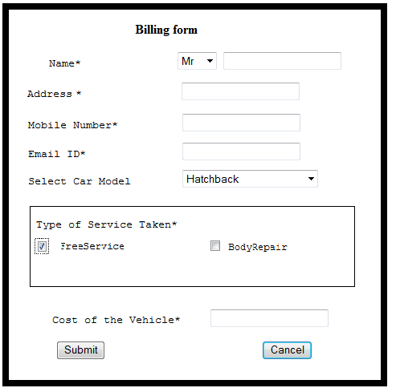

**Marks Distribution:**

|  |  |
| --- | --- |
| **HTML5 and CSS3 functionality** |  |
| Displaying the form correctly | 5 |
| Validating the form using HTML 5 attributes | 6 |
| CSS Usage | 5 |
| **Javascript functionality** |  |
| Calculating the Final Bill | 5 |
| Submit button functionality | 4 |

***SQL Server 2012***

**Note** – Q1 & Q2 (4) are compulsory questions. You can attempt any 2 questions from the rest.

Q1. Create tables with following specifications & Insert 5 rows.

* + - * Emp:EmpID, EmpName,Emp_Address,Emp_DOJ,Emp_Designation,Emp_Level
      * Leave_Details: EmpID, Leave_days, Reason, Leave_Type, Leave_Available, Leave_Availed and Leave Balance

|  |  |  |  |  |  |
| --- | --- | --- | --- | --- | --- |
| EmpID | EmpName | EmpCity | EmpDOJ | Emp Designation | Emp Level |
| 626262 | Gauri Bhide | Mumbai | 1/06/2013 | SSE | 3 |

|  |  |  |  |  |  |  |
| --- | --- | --- | --- | --- | --- | --- |
| EmpID | Leave Days | Reason | Leave_type | Leave_Available | Leave_Availed | Leave_Balance |
| 626262 | 2 | Personal | CL | 4 | 2 | To be calculated |

The leave balance should be calculated based on Leave available and Leave availed.

Q. 2

1. Display the count of CL taken by all SSE.
2. Display the Leave_Available,Leave_Availed,Leave Balance for Employees who reside in Mumbai.
3. Display the number of leaves balance for all the employees, who resides in city “Pune” or is having designation as “Team Leader”.
4. Create a Stored Procedure to Insert record in Leave Details Table. Display the definition of the stored procedure.
5. Create a view named Leave_Det_view which displays the Leave details of all employees who’s JoiningDate is between 01/01/2014 to 01/06/2015

***XML***

1. Write XML document based on Employee table in section 3.
2. Create a Schema for the XML file and write the appropriate restrictions and validate the XML file.